Full Body Study Questionnaire
All information given in the questionnaire will remain strictly confidential and will only be released to the reporting thermographer and any other practitioner that you specify.
Name: Birthdate
Address:

City Zip
Phone:
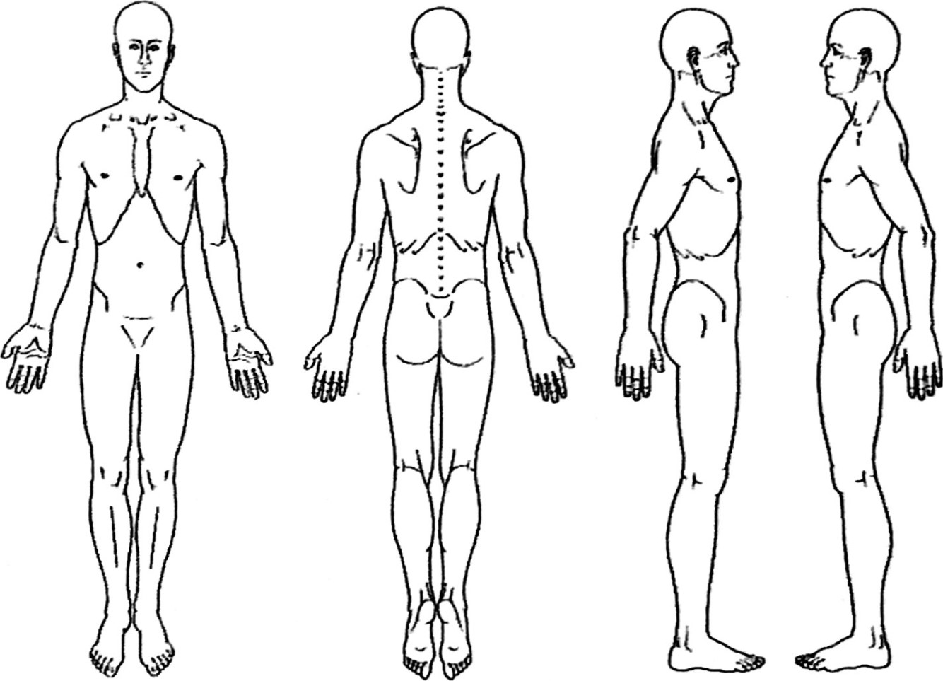
Please Show areas of :
Main Pain
Secondary Pain
Numbness
Pins and needles
Skin lesions / scaring
Do you know what tiggered the pain?
Does anytiing relieve it?
Does anytiing aggravate it?
Has it changed since it began? Have you had any treatment?
Any history of injuries, fractures, or surgeries?

PATIENT DISCLOSURE
I understand that the Report generated from my images is intended for use by trained health care providers to assist in evaluation, diagnosis and treatment. I further understand that the Report is not intended to be used by individuals for self-evaluation or self-diagnosis.
I understand that the Report will not tell me whether I have any illness, disease, or other condition but will be an analysis of the Images with respect only to the thermographic findings of the areas discussed in the Report.
By signing below, I certify that I have read and understand the statements above and consent to the examination.

